AQA GCSE Art & Design Assessment Criteria 2017

General grading guidelines: Grade boundaries have not been set and can change so view with caution.

- Exceptional ability: Grades 8 and 9
- Highly Developed ability: Grades 7 and 8
- Consistent Ability: Grades 5 and 6
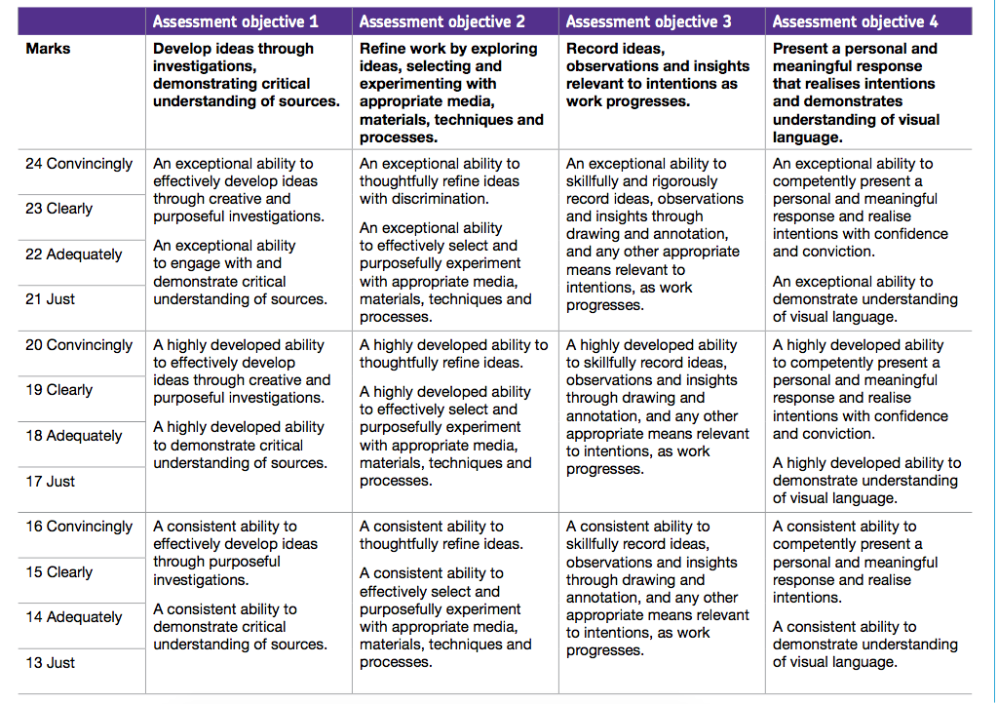
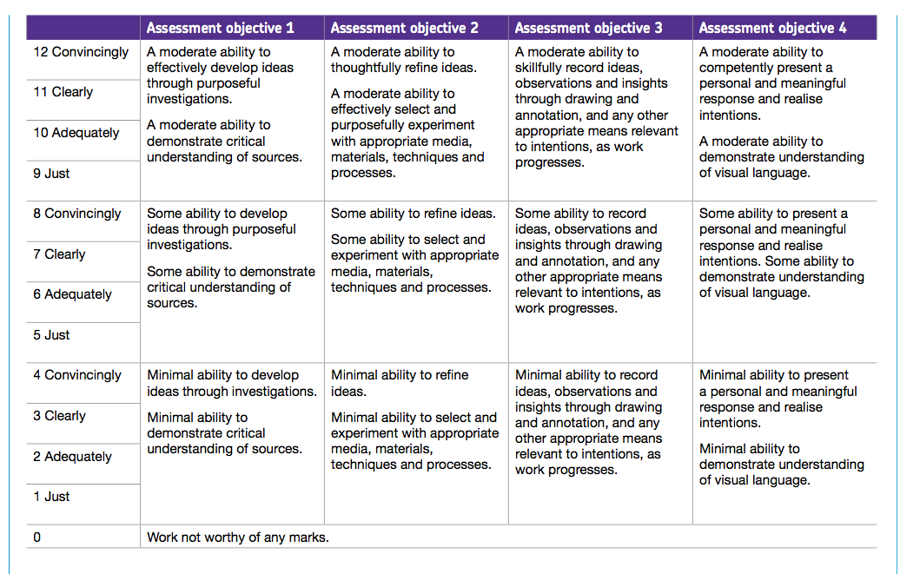
- Moderate ability: Grades 3 and 4

